**Tugas Praktikum OOP Modul 1**

Nama : Ryan Muhammad Satria

NIM : 1202210047

Kelas : SI4509

Link : <https://github.com/ryanmoehs/OOP-FATH-RYAN-1202210047/tree/master/Modul%201>

1. Screenshot Server.java

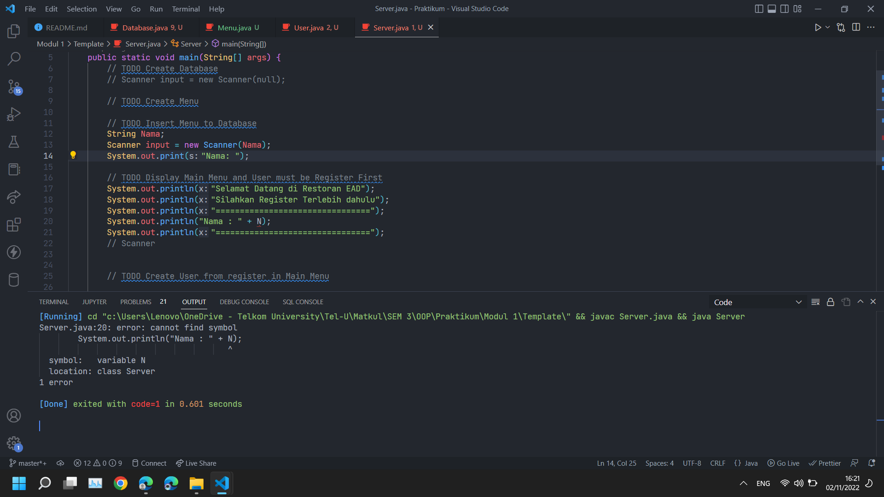

1. Screenshot Menu.java

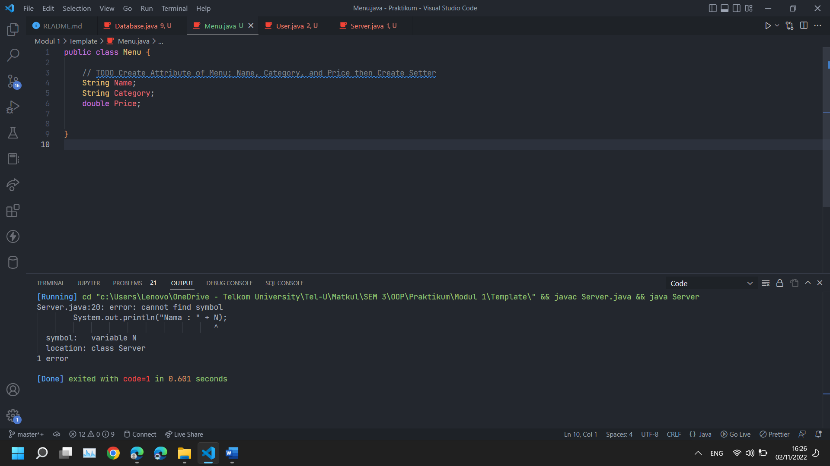

1. Screenshot User.java

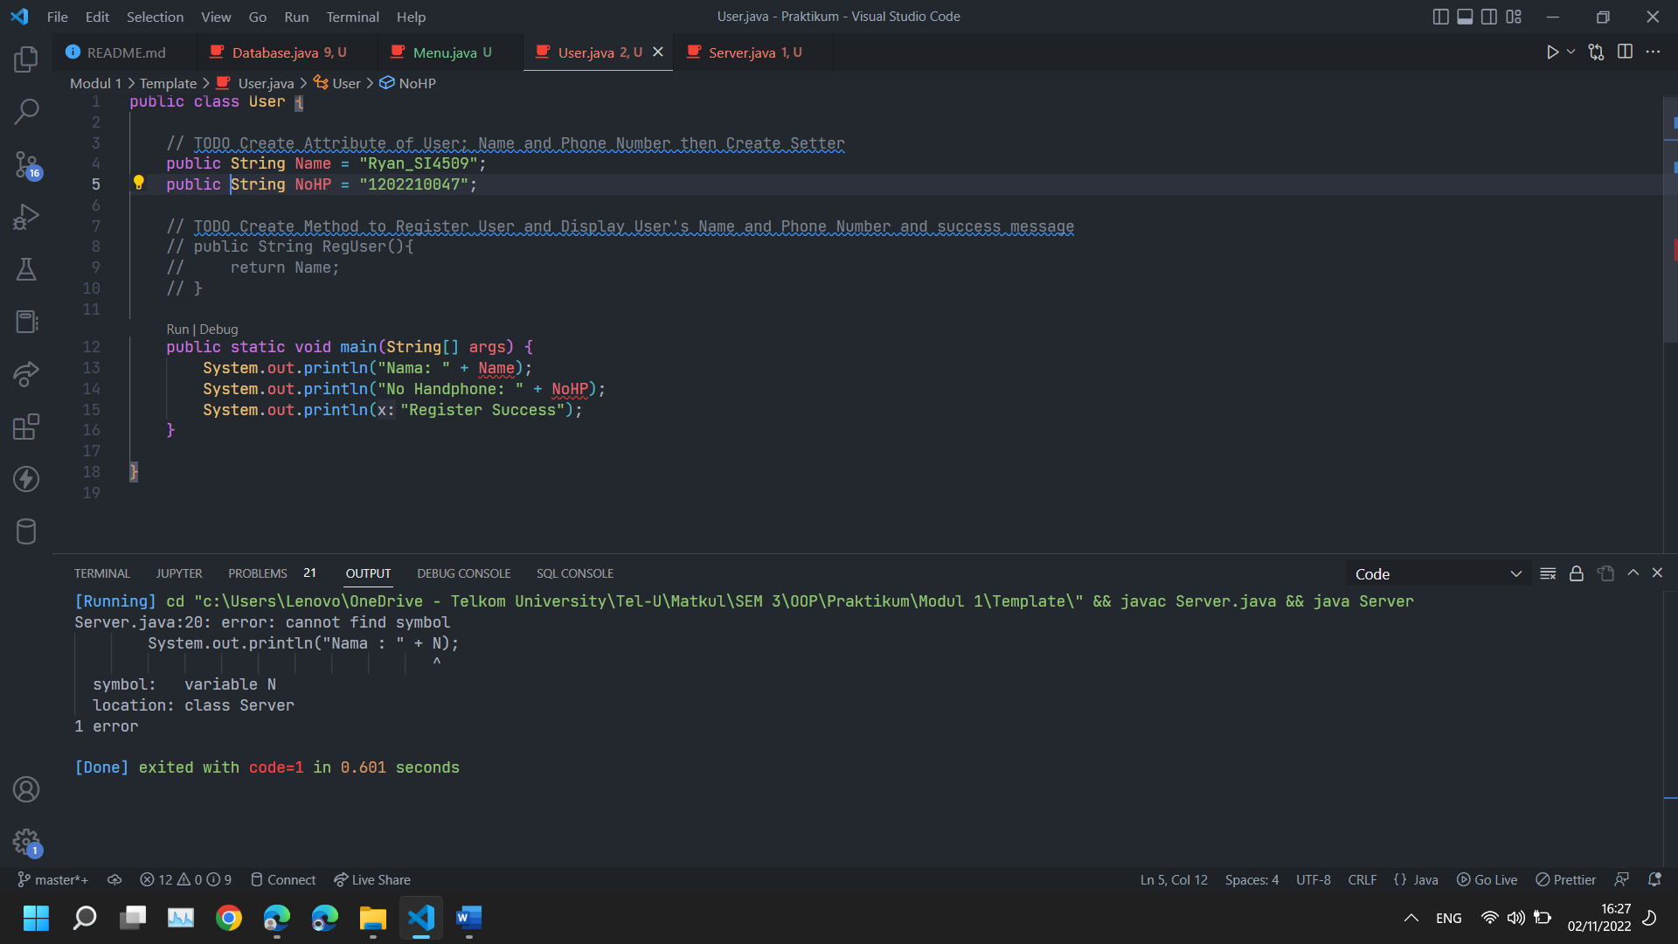

1. Screenshot Database.java

